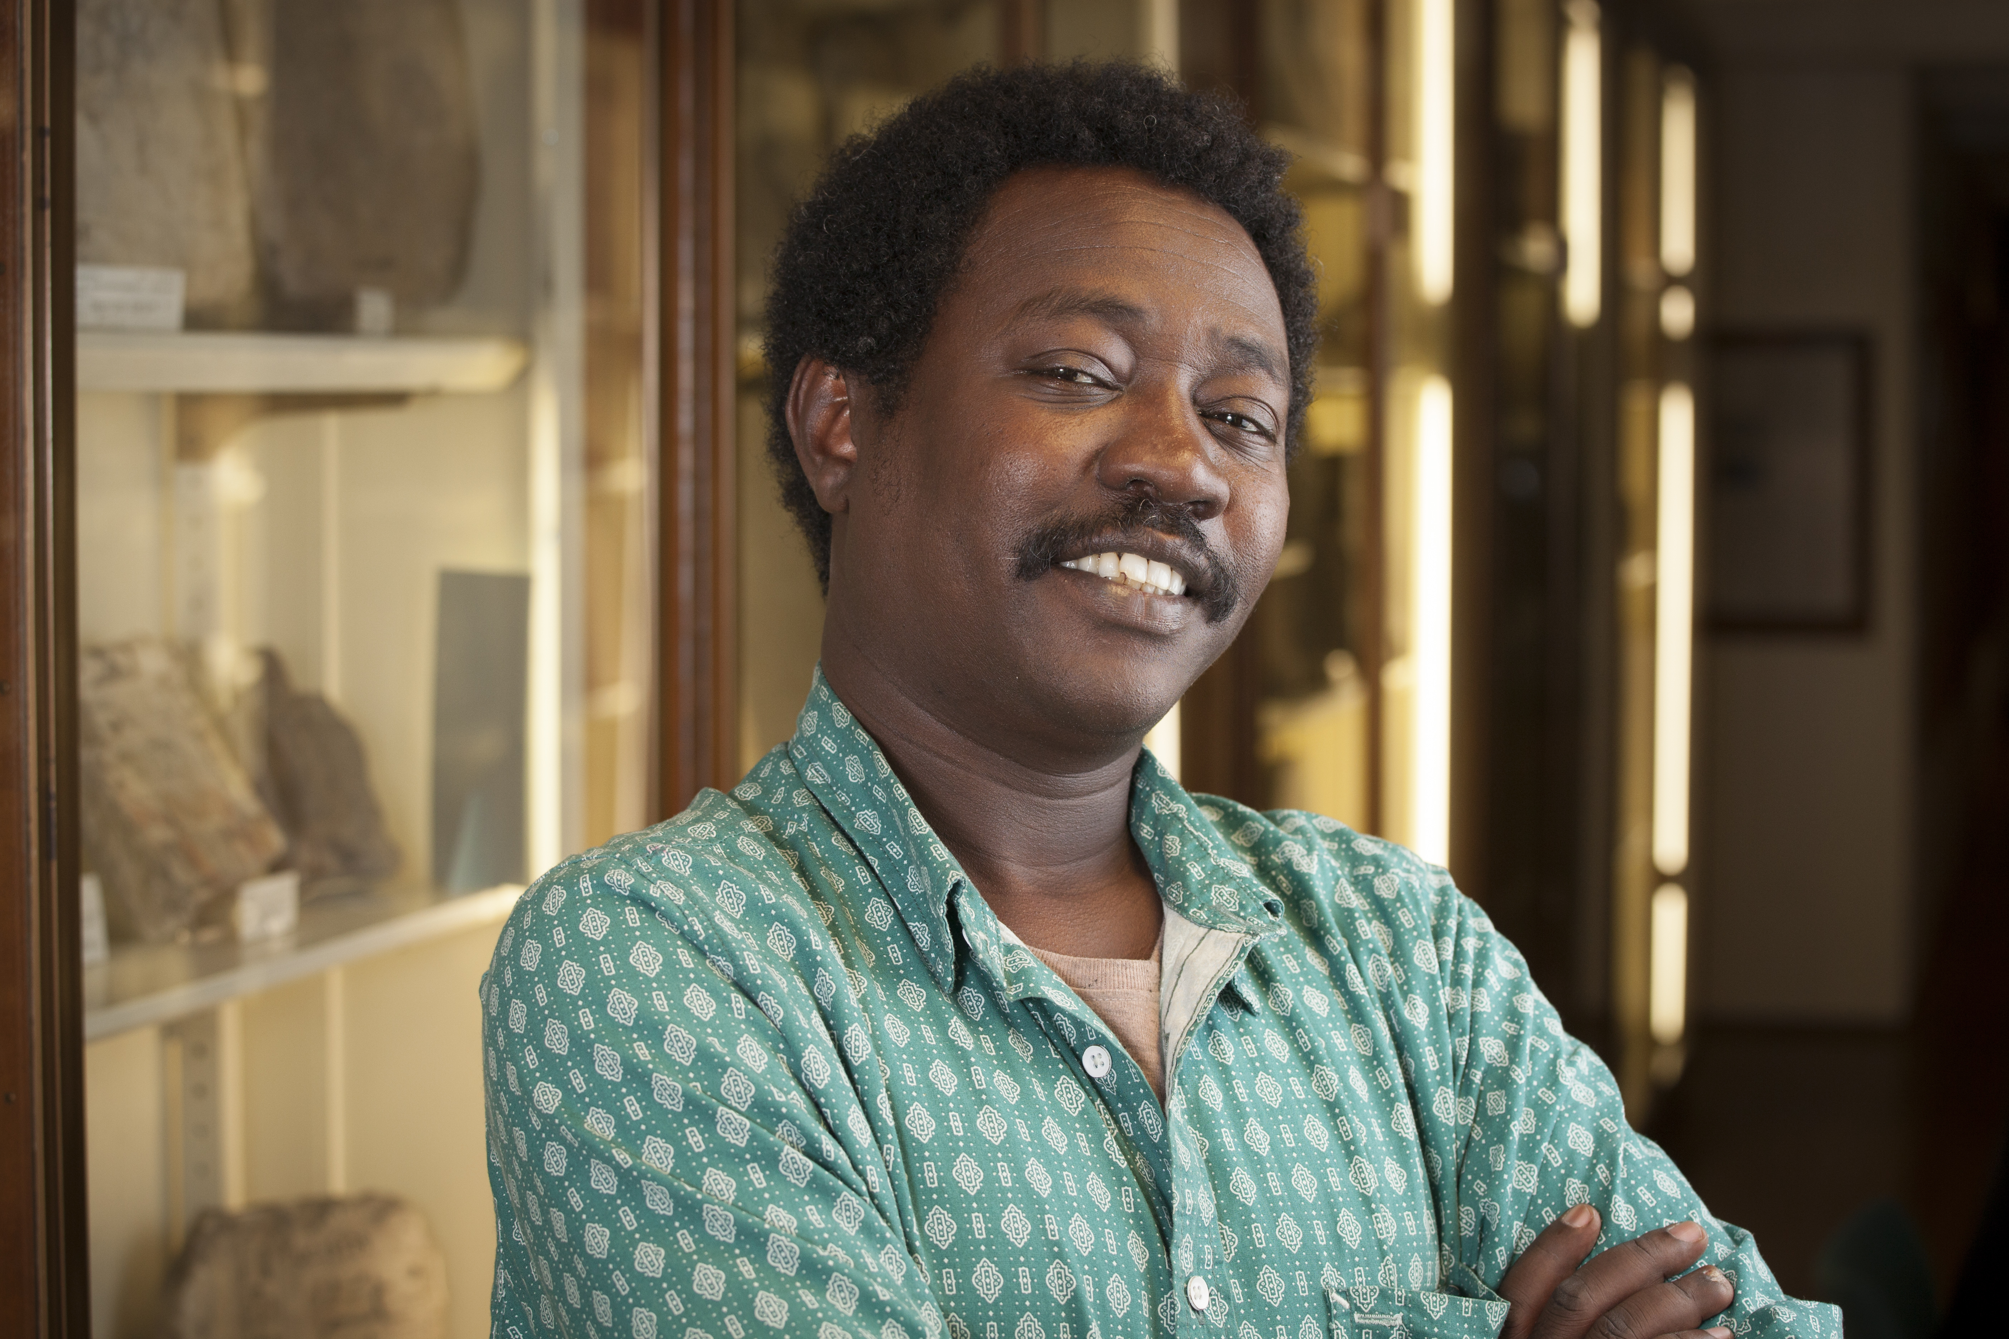

Name: al-Saddiq al-Raddi

Originally from: Sudan

Came to the UK: 2012

www.tracesproject.org/al-sadiq-al-raddi/



Name: Emad Altaay

Originally from: Iraq

Came to the UK: 2009

www.tracesproject.org/emad-altaay/

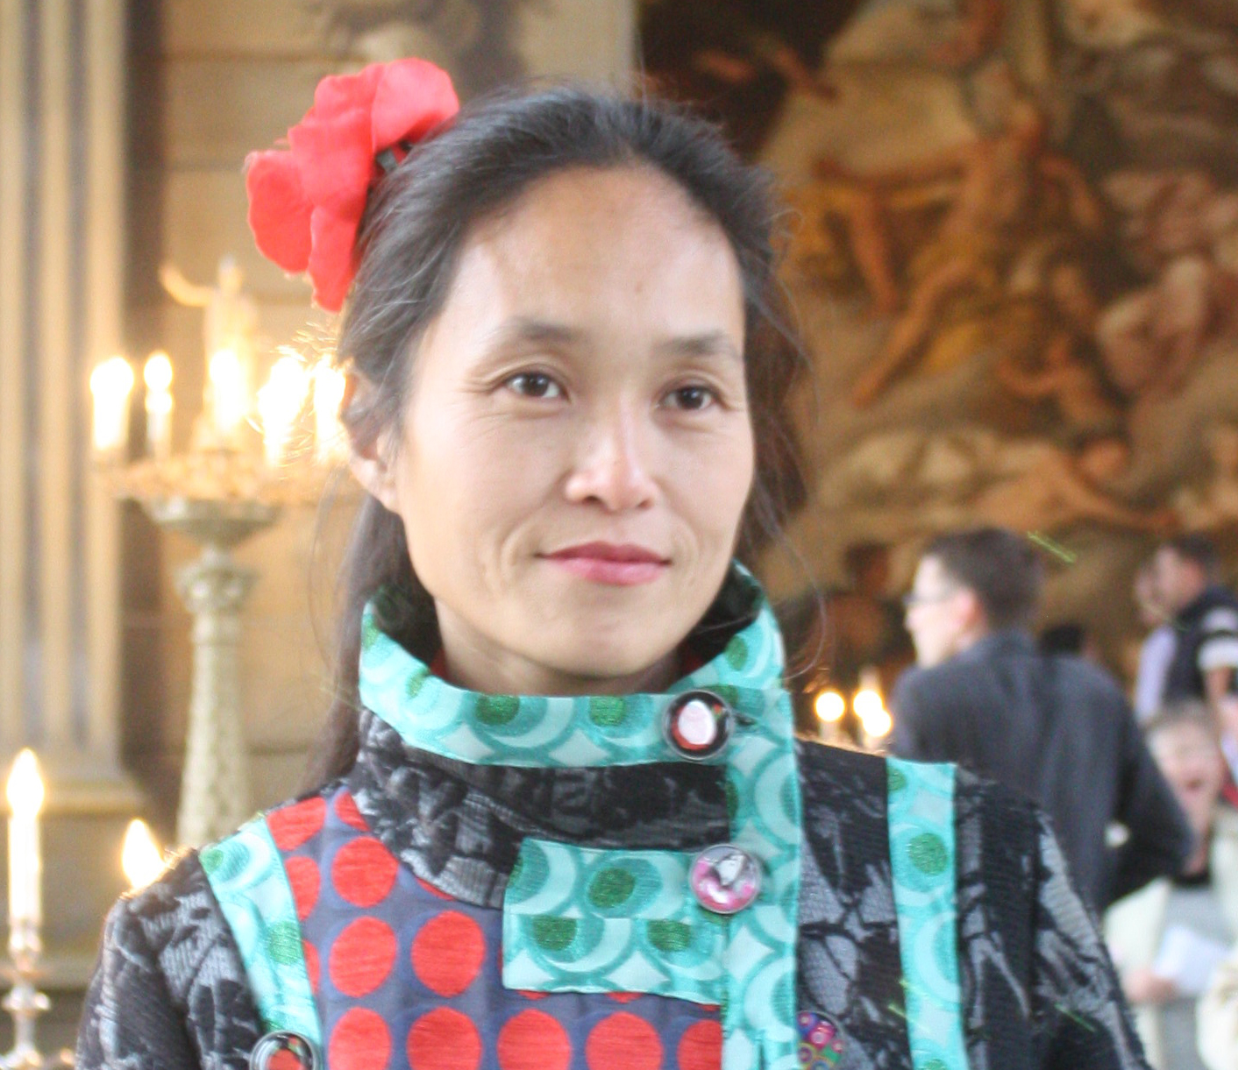
Name: Rita Ora

Originally from: Kosovo

Came to the UK: 1991

www.tracesproject.org/rita-ora/



Name: Hong Dam

Originally from: Vietnam

Came to the UK: 1980

www.tracesproject.org/hong-dam/

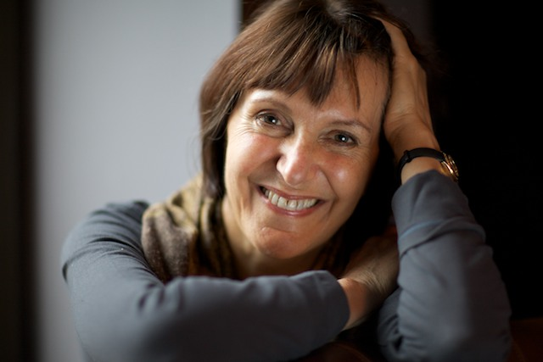

Name: Marina Lewycka

Originally from: Ukraine

Came to the UK: 1947

www.tracesproject.org/marina-lewycka-1947/

