The Unknown Soldier: History
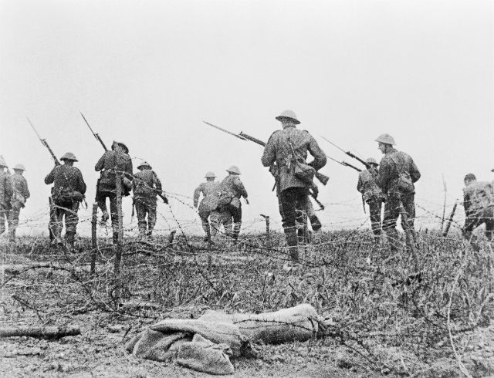
© Imperial War Museums

Learning objectives

Young people will:
- Have increased understanding of the humanitarian impact of armed conflict
- Explore feelings and emotions of people involved in, and affected by, armed conflict
- Have greater respect for human life and dignity
- Respect the values and the principles underpinning International Humanitarian Law
Age range: 14–19-year-olds

Introduction
This resource is based on the short film The Unknown Soldier and has been designed to combine the learning objectives above with aspects of teaching History.

We recommend you read the introductory sheet before using this resource.

This resource has been created for delivery over two sessions and the content has been organised in this way, but the structure can be adapted to suite your own teaching.

Additional supporting activities also accompany this session plan.

WWI is primarily covered through History for ages 11–14. Further aspects are covered through History options for ages 14–19, depending on the curricula or exam specifications being followed.
Owing to the variety in curricula, this resource:

- provides a session for History pupils to progress onto areas of related study at ages 14–19

- gives historical context to the other resources that make up this suite, and enables deeper understanding and engagement with the subject

- can be used as a stand-alone resource that could be linked to Remembrance Day events or to WWI Centenary activities/learning.

Young people will:

- use the film to explore why it is relevant to think about and remember WWI today
- think about how a historical perspective can help us to better understand modern day conflicts and empathise with those involved in them
- reflect on how conflict and how the impact it has on people has changed over the past century.

Session one: Remembering WWI
- Begin by asking young people what they know about WWI. You could do this as a whole group discussion or alternatively organise learners into small groups and give them a sheet of A3 paper to collectively gather their ideas. [At this stage an open recollection should be encouraged - the aim is not to determine right or wrong, but to get an overview of their current understanding.]

If using the small groups approach, ask each group in turn to share something from their discussions in order to build a collective group understanding.

- Next, ask young people to critically review their knowledge of WWI.

They could consider how much of what they know is factual information (dates, locations, names, numbers, events, etc.) and how much is emotional information (feelings, attitudes, values, etc.) that show the humanitarian impact of the conflict.

To ‘unpack’ this further, lead a whole group discussion in response to the following:

- When we remember WWI as a historical event is it more important to remember the factual or the emotional aspects of the conflict and why? If you consider both to be important why might this be?

- Which aspects are more effective in creating a connection with those who were involved in and affected by the conflict?

- Explain that you are now going to show a short film (less than 3 mins long) that was made recently by a filmmaker who thought it was important to remind young people about the events of WWI.

Ask them to watch the film in silence (explaining that the sound is an important part of the experience).

When the film finishes invite learners to give a one word response to the film and record these in a way that they can be seen, shared and possibly returned to for later use.

- Building on step one above, ask them what new knowledge or understanding they have gleaned from the film. If they were recording their ideas in small groups they could add these additional ideas in different colour, or perhaps by underlining or circling them.

Ask the groups if the film provided more factual or emotional information about WWI? [You could suggest that they mind map the information gleaned from the film on a large sheet of paper to help them draw this out.]

- Provide learners with the following information available on a worksheet from the Director of the film Joe Higgins:

‘One of the main reasons we made this film was to try and give young people today an understanding of an event that may have seemed distant or even irrelevant. We made the film in the hope it would spark an interest and inspire young people to learn more about the war and question what place conflict has in society both 100 years ago and today.’

‘…the film raises a number of issues that are still relevant today. Within the last year there have been many reports from different parts of the world where people are faced with horrendous choices. I hope the film will make viewers think about conflict, the choices people are sometimes forced to make and the consequences of those decisions.’

Ask learners to reflect on their own experience of watching the film and the intentions of the Director.

Lead a short closing discussion based on the following prompts:

- To what extent was the Director successful in making a meaningful connection with distant events?

- What made the film meaningful?

- How could thinking about what life was like for soldiers in WWI help us better understand the impact of modern day conflicts?

- Why might our emotive responses and feelings about past events be especially powerful in understanding the humanitarian impact of conflict?

Session two: Making humanitarian connections

- Remind young people that the previous session focused on revealing the humanitarian aspects of history – the impact an event has on people.

Through the film they explored how a humanitarian perspective can create more meaningful connections with the past.

You may wish to review the film again in order to refresh learners’ memories.

- Director, Joe Higgins, quoted during an interview about his film:

“Those who cannot remember the past are condemned to repeat it”

Before going on to say:

‘… it is only by learning from the mistakes of history that we can hope to avoid making them again in the future.’

Ask learners to think about these quotes in small groups and to use their historical understanding (both factual and emotional) of WWI to review the humanitarian impact of the conflict and the lessons that can be learned.

The following framework may help learners to think this through:

Issue/event | Humanitarian impact/s | Lessons learned
E.g. forcing soldiers to go over the top | Death, wounding and in some cases of survival long-term mental illness/trauma/insomnia | Welfare and improved treatment and support for own soldiers, end of conscription etc.
E.g. being separated from loved ones with little communication | Increases feelings of isolation and despair while on active service as well as impacting on those at home. | Increase in communication for soldiers with their loved ones.

Give learners around 10–15 minutes to collate their initial ideas and then ask them to pause, but to keep their work to come back to later.

- Introduce young people to the idea of International Humanitarian Law (IHL). Explain that this is a series of laws that apply to international armed conflict and seek to limit the effects of war. IHL is sometimes referred to as the Rules of War.

Show learners the short animation ‘The Rules of War in a Nutshell’ to give them an overview of IHL and some of the issues and events that have informed its development.

Following the film provide learners (still working in their small groups) with access to the ICRC web page 150 years of humanitarian action and ask them to build their understanding of issues, impacts and lessons learned using the interactive timeline as an historical resource. To support this the following key points can be shared:

- They can click on any of the events or periods in the main timeline window to access more detailed information in relation to humanitarian impact.

- They can build on the starting point of WWI but explore how later conflicts and their humanitarian impact have continued to shape IHL. They could add any new ideas into their table.

- Ask learners to research for information exploring the humanitarian impact of a more recent conflict – for example, Syria. What can they identify as the main humanitarian impacts from their research on current day conflicts?

- Using their research into the humanitarian impact of conflict over time, ask young people to reflect on how these impacts have changed since WWI. In their groups they should prepare a short (max. 5 minutes) presentation on:

‘the changing nature of conflict and its humanitarian impact’

or

‘how has conflict and the effect it has on people changed between WWI and today?’

The following could be given as prompts to support the process:

- How has the involvement of soldiers and civilians in conflict changed over time?
- How have the physical and psychological impacts of conflict on people changed since WWI?
- How have the weapons used and their impacts on people changed over time?
- Has the impact of conflict become wider (i.e. felt more globally) than in the past? If so then in what ways?
- Is there greater awareness of the humanitarian impact of conflict and IHL than in the past?

Allow young people to explore this freely in their groups and give them time to form some ideas before presenting back. They could choose to present back using a poster, a PowerPoint presentation, or a dramatised time line (with each person narrating a change over time).

- Using insights from the presentations into how the humanitarian impact of conflict has changed over time, work as a group to write down ideas as to what the key challenges might be for organisations like the Red Cross that give humanitarian support to those affected by conflict.

After initial ideas have been shared, ask learners to return in their smaller groups to the 150 years of humanitarian action site and click on the link ‘contemporary humanitarian challenges’ below the timeline.

This will give them a wider perspective on the challenges and they can compare their own ideas with those on the ICRC site.

- As a final reflection ask young people to think about how they have connected the events of WWI to contemporary understandings of conflict and its humanitarian impact.

Explain that one way people remember these connections is through events such as Remembrance Day when a moment of silence is observed to make those connections. Give them a moment of silence to think about the connections and memories they have made during the sessions.

Close the session by asking young people what they would say to someone (a friend or family member perhaps) who asked “Why is it relevant to remember and think about WWI today?”

They may like to come up with their own quote similar to that quoted by Joe Higgins in step two above. These could form the basis of a display within the school, perhaps tied to Remembrance Day.

