The Unknown Soldier: Introduction

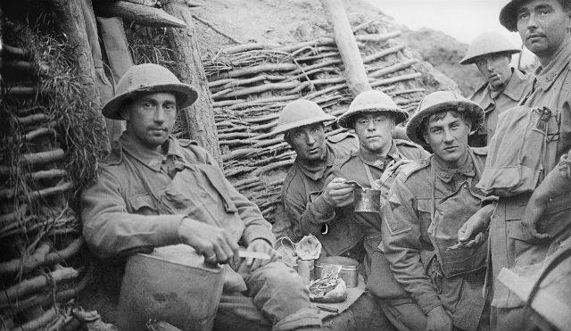
© Imperial War Museums

Overview
The British Red Cross and Lifeworlds Learning have created a suite of World War One (WWI) resources for key stage 4 and 5 secondary teachers, suitable for use with 14- to 19-year-olds.

Five curriculum-linked session plans and short activities link to a short film called The Unknown Soldier.

The film
The film depicts life in WWI trenches in the moments before soldiers go over the top and into battle.

The film is directed as though the viewer is present and is intended to stimulate reflection on what life might have been like for soldiers involved in WWI.

It encourages young people to think about the impact of conflict – both then and now – on the people involved.

Learning objectives
Through engaging with the activities in the session plans, young people will work towards a range of humanitarian learning objectives. In particular, young people will:
- Have increased understanding of the humanitarian impact of armed conflict
- Explore feelings and emotions of people involved in, and affected by, armed conflict
- Have greater respect for human life and dignity
- Respect the values and the principles underpinning International Humanitarian Law

Contents
- Introduction
- Supporting activities
- Session plan: Media studies
- Session plan: Drama
- Session plan: English
- Session plan: Citizenship
- Session plan: History

Session plans

Each session is focussed around a specific subject or curriculum area and draws on relevant aspects of the film.

Each of these has been written as a learning pathway which can span over two or three sessions.

Individual components of the resources could be used independently if you wanted to design a shorter or one-off session.

Supporting activities

There is also a set of stand-alone activities that engage with the film more generally.

These supporting activities could be used in combination with the subject resources (as a starting point) or as freestanding activities (in form/tutor time for example).

These activities could also be used as the basis for planning an assembly with a little adaptation.

An adaptable learning pathway
Each resource has been organised as a step-by-step pathway that gradually builds the learning for students.

This is only a suggested pathway and there is enough flexibility within the resources for educators to develop their own way of using the resources. Each resource begins by setting out the learning objectives from both a humanitarian education and subject perspective.

Although presented as separate resources, teachers could use individual activities from across the subject areas to create their own pathway through these materials. This option may be useful if planning thematic work at a whole school/key stage level for example.

In this way the content could be linked to broader learning opportunities such as learning around Remembrance Day or the commemoration of 100 years since the events of WWI.

A note on the film

The film portrays life in WWI trenches and includes scenes of shouting, of someone being sick and of death.

All are relevant to the film and its context. They are not gratuitous and form part of the learning, but owing to the nature of the film it is strongly advised that teachers review the film before showing it to young people.

The film makes use of new sound technology and is intended for viewing whilst wearing headphones in order to gain the full impact.

This may not always be possible and the resources and activities are still relevant if the film is viewed as a class and without headphones.

The exception is in the media studies resource where the use of sound forms and integral part of the learning.

Related resources
Access a range of related Red Cross online teaching resources and help your students further their humanitarian learning.

First World War volunteers Over 90,000 people volunteered for the British Red Cross at home and overseas during the war. This unique set of teaching resources encourages young people to discover more about the roles volunteers played during the war.

Rules of war Pick and choose from our rules of war resources to create thought-provoking sessions in which young people can explore core humanitarian principles and how they can be applied situations of armed conflict.

Humanitarianism in action Begin by exploring the term humanity. Move on to consider dilemmas in situations where a humanitarian response is possible. Explore social pressures and barriers to action around helping others. Conclude by reflecting on what motivates people to act to help others.

Humanitarianism and the Red Cross Humanitarianism is at the heart of the International Red Cross and Red Crescent Movement, guiding all that it does and everything it stands for. The activities in this resource support young people to learn about the formation of the Movement before looking at the principles underpinning its work and real-life examples of its actions.

