Refugees: Welcome – key facts 2016

Key terms and language
Discussion around refugees and the movement of people can involve lots of different terms.

It is important to know and understand the difference between these because they can mean very different things, not only in words, but for the people involved.

Here are some of the key terms.
Refugee - A person who owing to a well-founded fear of being persecuted for reasons of race, religion, nationality, membership of a particular social group or political opinion, has left their home country, As a result they are unable or unwilling to seek protection from, or return to, their home country.

Asylum seeker - Someone who has left their home country and formally applied for recognition as a refugee in another country and is waiting for a decision on their application.

Internally displaced person - Someone who has been forced to leave their home, often because of conflict, and has had to relocate or been forcibly relocated to another area within their home country.

Labour migrant - Someone who migrates for the purposes of employment. The term economic migration is sometimes used interchangeably with labour migration. However economic migration is broader and can encompass migration for the purposes of improving quality of life in social and economic terms.

Irregular migrant - Someone who does not hold the required legal status or travel documents to enter or remain in a country.

Migrant - Someone who leaves or flees their home and travels to live in another country or region.

Migration can be temporary or permanent and can be for a variety of reasons including to seek opportunities or safer and better prospects.

The term migrant is therefore broad and can include asylum seekers, refugees, internally displaced people, labour or economic migrants, and irregular migrants.

The refugee crisis in Europe
Since early 2015 Europe has been said to be facing a refugee crisis.

A crisis can be on a large or small scale. It can involve whole countries or be a situation where someone needs help, whether because they are lonely, stranded, ill or finding it hard to cope.
A crisis can affect individuals, families, or whole communities and countries.

The current refugee crisis in Europe is caused by:

- the largest number of people fleeing violence and conflict since the Second World War (1939-45)
- more than one million refugees or migrants reaching Europe in 2015 and over 150,000 more arriving in the first three months of 2016.
- extreme danger in a number of countries from which people are fleeing because of fear of violence, conflict or persecution. These countries include Syria, Afghanistan, Iraq, Somalia, Sudan, and South Sudan,
- people, including many children being forced to make dangerous journeys to Europe and arriving hungry, ill, traumatised and with few or no possessions or money.

Refugees in the UK and the bigger picture
Many thousands of people are suffering a real crisis as they reach Europe.

This has sometimes been reported as a problem or threat for the UK. Words like ‘invasion’, ‘swarm’ and ‘tidal wave’ have been used by some to describe the situation, but what is the reality?

Here are some facts and figures to help.

60 million – the number of people worldwide fleeing conflict, violence or persecution

15.1 million – the number of refugees worldwide

169 – the number of countries or territories worldwide that are hosting refugees

8.7 million – the number of refugees hosted by the top ten countries: Turkey, Pakistan, Lebanon, Iran, Ethiopia, Jordan, Kenya, Uganda, Chad, Sudan

80% – the proportion of refugees hosted by developing countries (see map)

126,000 – the number of refugees living in the UK (just 0.19% of the UK population of 64.1 million)

38,878 – UK asylum applications in 2015 (compared to Germany - 431,000, Sweden - 163,000, and Hungary - 163,000)

45% – the percentage of successful asylum applicants allowed to stay in the UK in 2015.

World map showing the location of the world’s refugees in 2015
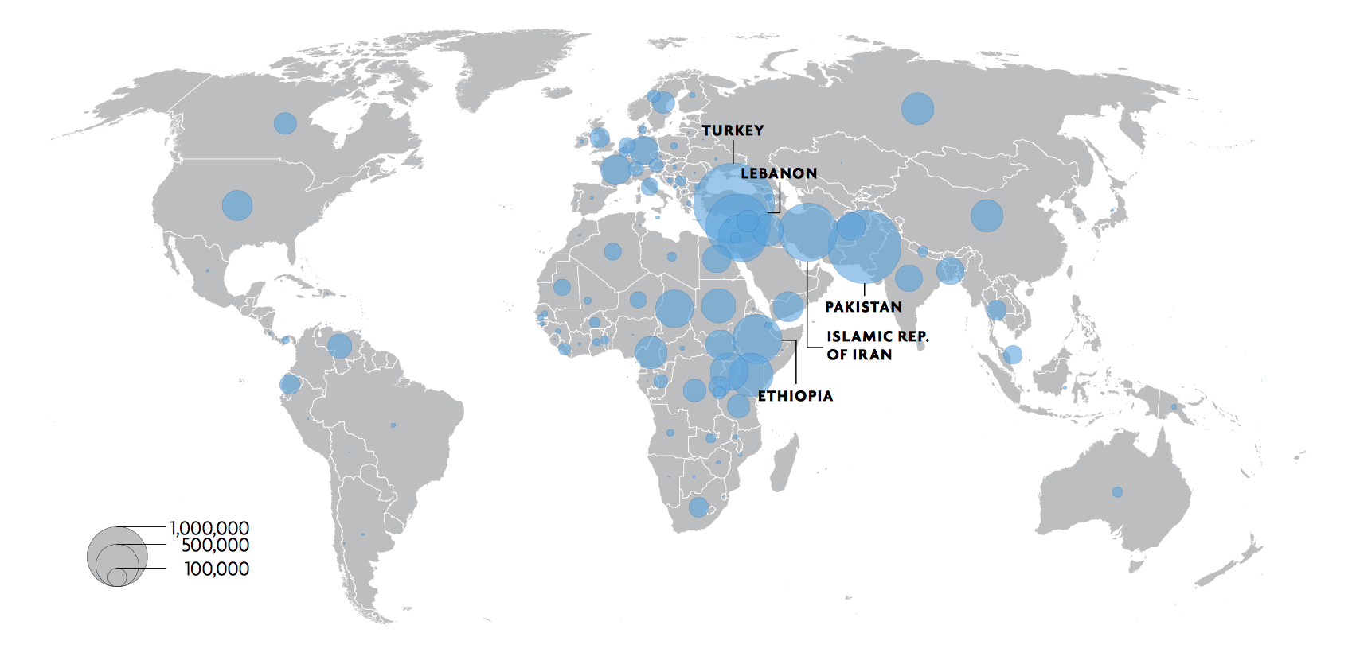

© 2015 United Nations High Commissioner for Refugees

Source: adapted from the definitions in the 1951 United Nations Convention Relating to the Status of Refugees
Source: Adapted from a definition cited in the UNESCO glossary on migration www.unesco.org/shs/migration/ glossary.
UNHCR Mid Year Report 2015 - http://www.unhcr.org/56701b969.html#_ga=1.181376295.1852304914.1460365350
UNHCR Mid Year Report 2015 - http://www.unhcr.org/56701b969.html#_ga=1.181376295.1852304914.1460365350
UNHCR Mid Year Report 2015 - http://www.unhcr.org/56701b969.html#_ga=1.181376295.1852304914.1460365350
UNHCR Mid Year Report 2015 - http://www.unhcr.org/56701b969.html#_ga=1.181376295.1852304914.1460365350
http://www.redcross.org.uk/What-we-do/Refugee-support/Refugee-facts-and-figures
http://www.redcross.org.uk/What-we-do/Refugee-support/Refugee-facts-and-figures
http://www.redcross.org.uk/What-we-do/Refugee-support/Refugee-facts-and-figures
http://www.redcross.org.uk/What-we-do/Refugee-support/Refugee-facts-and-figures
UNHCR Mid Year Report 2015 - http://www.unhcr.org/56701b969.html#_ga=1.181376295.1852304914.1460365350

