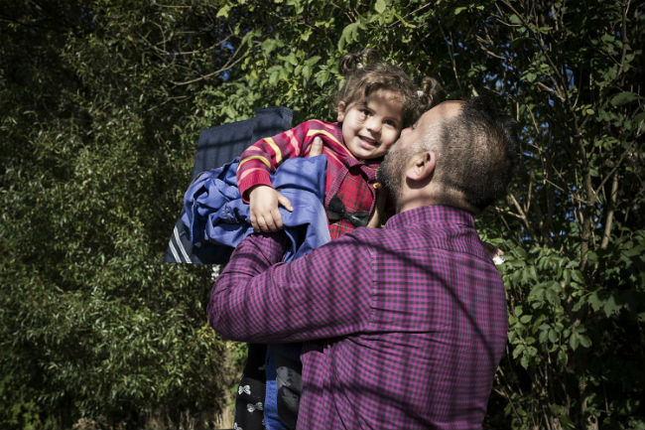
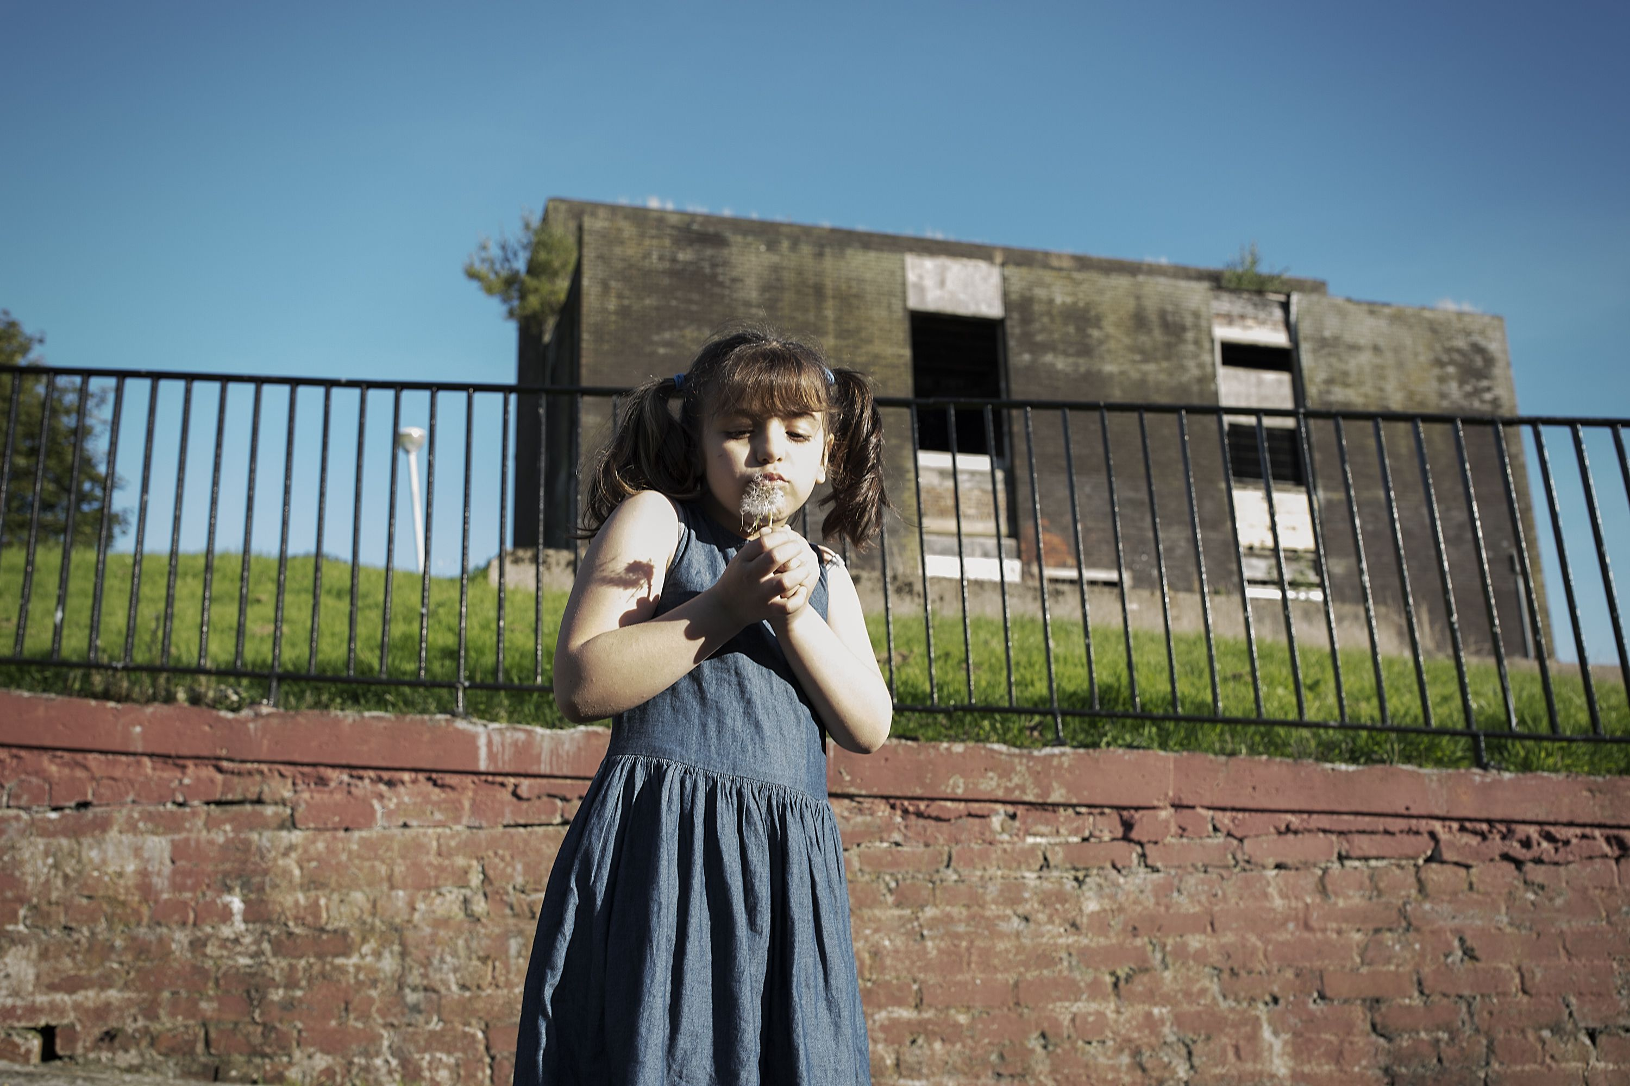
Mohammad and Kamaar’s story

Mohammad was a very successful businessman. His thriving company employed 25 people. He provided for his wife, Kamaar, and their seven children and was proud that he could also help people in his community when they were in need.

He had even built the family their dream home, but after living it in for just six months it was destroyed by a rocket attack. The blast left one of his little girls, Yamat, almost completely deaf.
Very quickly, the family’s dream life had become a nightmare.

Mohammad and his family fled from Syria to Egypt in what they thought would be a short term move until the fighting had stopped.

Eighteen months later, with no end to the conflict in sight, their life savings dwindling and the increased risk in Egypt, they decided they could no longer stay.

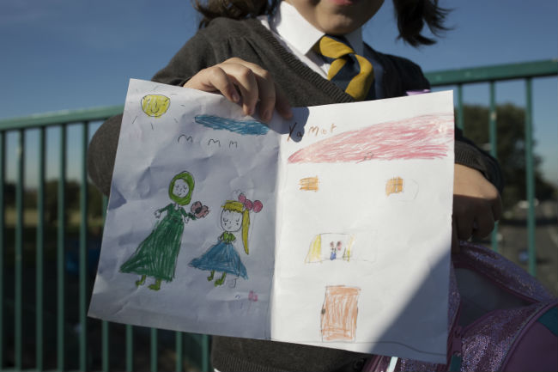
In May 2014 Mohammad made the treacherous journey across the Mediterranean with 450 people on a fishing boat. They were on the boat for 15 days before landing in Italy. He then travelled to Calais and eventually made the crossing to the UK, hidden in a refrigerated lorry for 15 hours.

He arrived in the UK in July and after his asylum claim was approved he contacted the Red Cross to help bring Kamaar and his children to Glasgow.

He constantly worried about his family in Egypt and couldn’t sleep at night knowing they had very little money left.
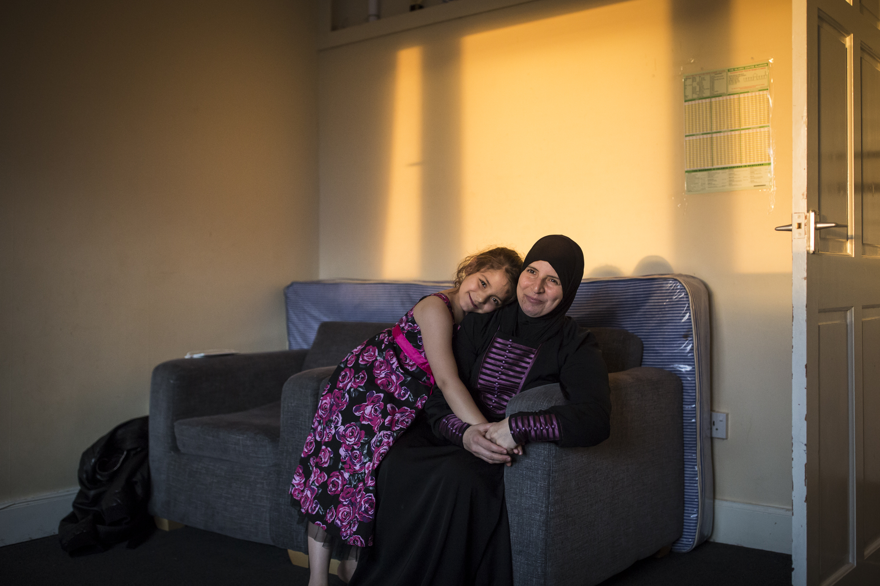
The family were reunited in February 2015.

Today, the family live in a cramped three-bedroom apartment in Glasgow. The bare walls feel a long way from the family’s prosperous life in Syria.

Yamat is waiting to be fitted with a hearing aid. She has total deafness in one ear and small amounts of hearing in the other, after the injury from the rocket attack.

All photos © Conor Ashleigh/British Red Cross
Text adapted from Sophie Offord/British Red Cross blog. Read more: http://blogs.redcross.org.uk/uk/2015/10/the-day-that-everything-changed-for-this-refugee-girl/

