Hope FC: why this man thinks football can change the world

By Sophie Offord
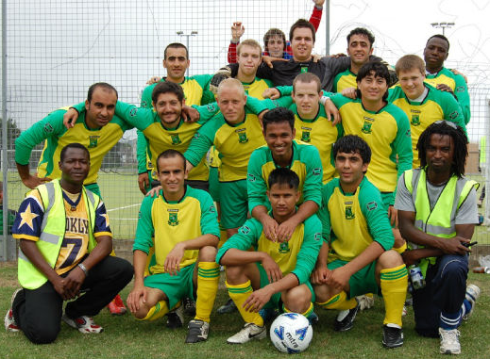
David Feindouno is using football to unite refugees and locals in his community. When he grew up, David wanted to be a footballer. Like many boys, he was obsessed with the “beautiful game”. But while studying Economics at university in Guinea, his life changed dramatically: David had to flee his home country.

He later arrived in Plymouth, southwest England, without any family or friends. He didn’t know anyone. David came across a local refugee centre, where he saw others in the same situation. He wanted to set up something for asylum seekers to use their time wisely and maybe even form friendships.
Plymouth Hope FC. David is bottom row, far left.

“Football is a worldwide sport,” David tells me. “What will bring people together, regardless of nationality and background? Football. Football does that.” He adds: “There are worldwide rules. You have to shake hands with the other players after a match. People don’t ask ‘Where are you from?’, ‘Why do you look different?’ You just play together. You accept each other.”

At the first football session in 2009, more than 50 people showed up. At first, everyone was a refugee or asylum seeker. But as time went on, the team grew into a good mix of locals and newcomers. David was thrilled. He says integration is at the heart of the project – and an important factor for asylum seekers.

Soon, regulars were coming along every week, eager for extra training. The players started asking about football kits and league tables. Things were getting serious, and the team needed a name.
David says: “We started by thinking, ‘What’s the purpose?’ People come to play football – but they also come to make friends and integrate into society. They hope to be accepted. We all have hope. ‘Hope’ means a lot to me, as a word. That’s why we’re known as Plymouth Hope FC.”

David, now 31, has worked really hard to promote his football team in the community. They now play in a couple of local leagues. The football team is also part of a registered charity: Plymouth Hope. This offers other activities too, such as youth mentoring and community events.

Source: http://blogs.redcross.org.uk/uk/2015/02/hope-fc-why-football-can-change-the-world/
12 February 2015

UK flooding: Syrian refugees help build flood defences near Manchester “to give something back”

By Lizzie Dearden
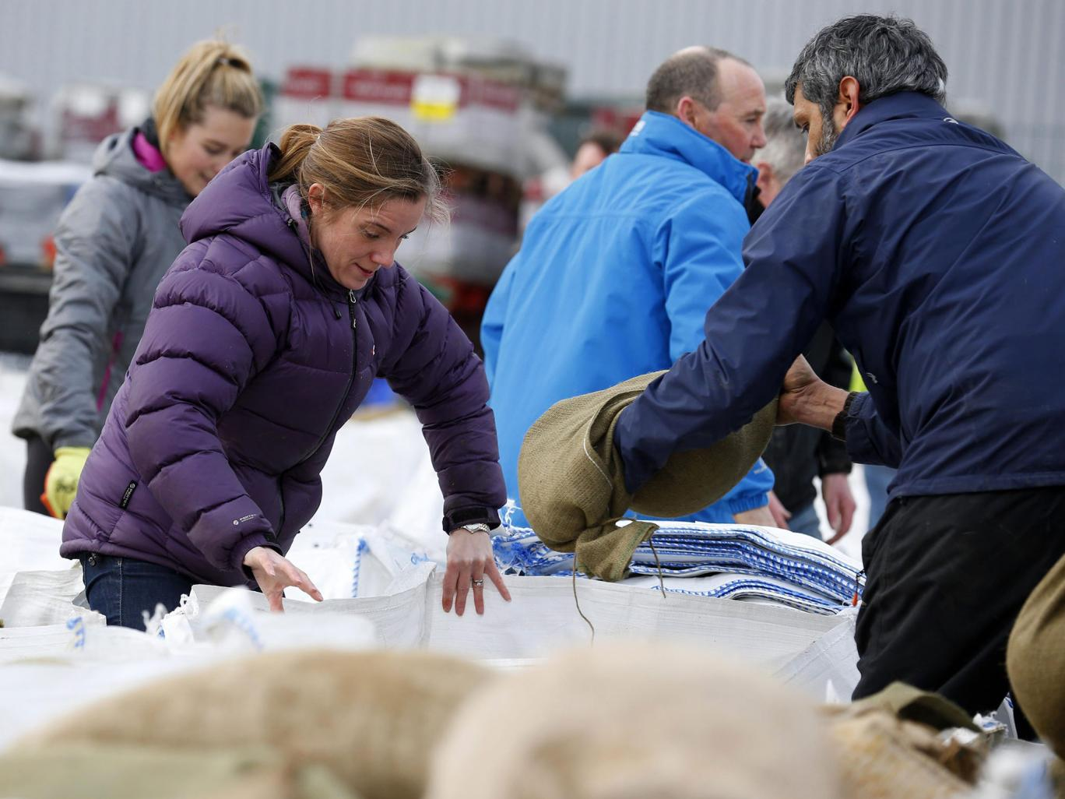
Local volunteers fill sandbags to stem flood water in York city centre. Photo: EPA
Syrian refugees have been helping to build flood defences to “give back” to the communities who have welcomed them in Manchester.

They were among volunteers filling sandbags in Littleborough on Tuesday after hundreds of homes were flooded when the River Roch burst its banks.

Yasser al-Jassem, who reached Europe through Greece, said he had seen images of the devastation on television and wanted to help.

“The people of Greater Manchester have been very good to us and so we wanted to offer our help to them,” he told the Manchester Evening News.

“As Syrian refugees, we are honoured to take part in community service initiatives such as this to give back to the communities that have so warmly taken us in.

“I put out a call through WhatsApp and immediately had many other Syrian refugees join me.

“It shows that we are very much interested in not only becoming a part of British society, but also contributing to it.”

Source: http://www.independent.co.uk/news/uk/home-news/uk-flooding-syrian-refugees-help-build-flood-defences-near-manchester-to-give-something-back-a6790421.html
30 December 2015

