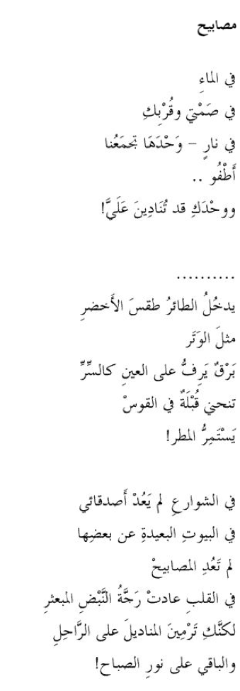

Lamps

In the water
in silence at your side
in a fire that draws us close
I drift -
and only you can call me

. . . . . . . . . .
A bird enters spring
like a lance
Your eyes flash their secrets
A kiss grazes the rainbow
The rain rains
But the streets are empty of my friends
Lamps are extinguished
in the far-flung houses
and the lost heart echoes in its lonely chamber
You give your blessings to those who depart
and leave the rest to fate
By al-Saddiq al-Raddi © Poetry Translation Centre 2015 http://www.poetrytranslation.org/poems/lamps

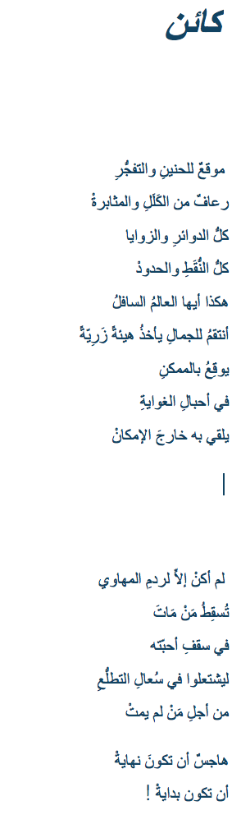
Someone

Site of longing and explosion
bleeding from exhaustion and diligence,
from all the circles and constraints
all the markers and borders
fixed in this bastard world

I wrench beauty from ugliness
and fall prey to possibility
In the knot of temptation
the possible is jettisoned

I am nothing but a digger of graves
The dead are abandoned
beneath the roof of their loved ones
They turn pale keeping watch
over those not yet dead

A nightmare that would end
is a nightmare that would begin

By al-Saddiq al-Raddi © Poetry Translation Centre 2015 http://www.poetrytranslation.org/poems/someone

