Surviving camp in monsoon rains
Hundreds of thousands of people who fled violence in Myanmar now live in makeshift camps in Bangladesh. Conditions in the camps offer only the rudiments of basic living. These photo discussion activities look at how the monsoon season could affect life in these camps, and encourage learners to consider the role and importance of hope during challenging times.

Suggested age range: 11–16
Curriculum links: PSHE

Starter: Photo activity
Invite the young people to share what they have heard of the camps and the lives of those who live there. If they have not heard anything, ask learners to imagine what life might be like. How might children there spend their time?
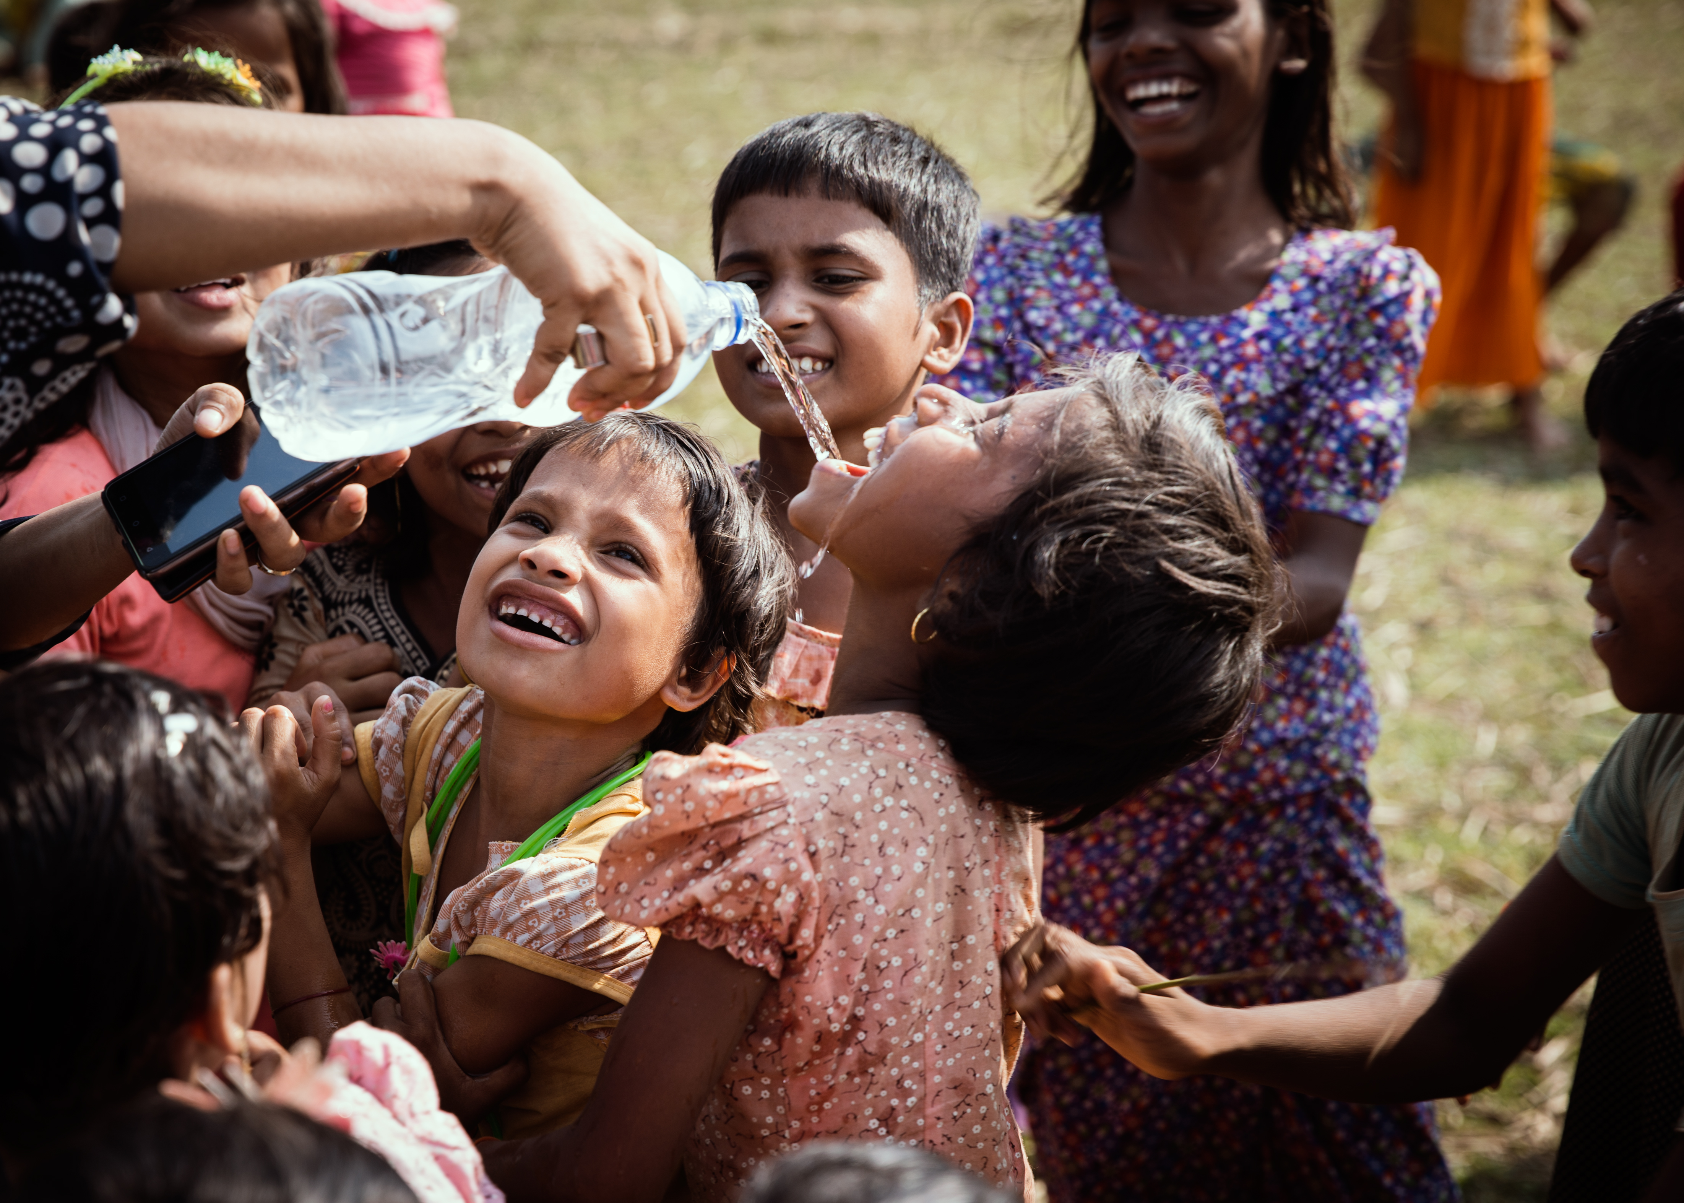

Display the photograph. It was taken in April this year in Kutupalong camp, in Cox's Bazar, Bangladesh.

Invite learners to think of words that sum up the mood of this photograph. Do the laughter and playfulness match learners’ views expressed earlier? What do they find the most striking? Is it possible to enjoy more light-hearted moments while living in difficult and unsafe conditions?

Ask learners if they can explain the meaning of “monsoon season”.

- The monsoon season is a period when the direction of the winds change, which can bring heavy rain to South and South East Asia in May to September.

Camp conditions
Display the images in slides 3–5 of the PowerPoint. They were taken by a British Red Cross aid worker in Cox's Bazar, Bangladesh, after days of rain in early June. They show how a route that normally takes 20 minutes to walk took aid workers an hour, as they had to walk through thick mud and makeshift bridges.

The monsoons happen every year, and people adapt their lives and homes to this event. Why do learners think the rainy season could be especially devastating for people in the camps? (Learners could look at the images for clues, or use the prompts below.)

- Shelters (the shelters were built quickly and might be flimsy and not able to withstand heavy rain)
- Number of people (the area is overcrowded, and makes the risk of disease higher)
- The location (the area is at risk of landslides and floods; it is a challenge to make the shelters more secure; access to food and water is limited)
- Hygiene (important services like washing facilities, toilets and water pumps could be washed away or flooded, which could lead to disease spreading)
Working together in small groups/pairs, ask learners to devise short captions to accompany the photos. Focus on how people might be feeling and what they might do to try to stay positive, what might help them and what they can do to help their loved ones.

Hope
Dr Jemilah Mahmood works for the International Federation of Red Cross and Red Crescent Societies. Display the quotation from when she spoke recently about the situation in the camps in Bangladesh as the season of monsoon rains approached:

- It’s a really daunting task. There are moments when I feel real despair, but there are moments when I feel real hope – because of this indomitable human spirit of togetherness.
Consider the importance of hope during challenging times. How much more difficult is being hopeful when rains come, when ordinary tasks become slow and laborious?

Invite learners to think about how despair and hope can coexist. What helps people through challenging times? How might people help each other to keep up their spirits and solve practical problems? What gives people hope?

Extension activity
The crisis facing people in the camps in Bangladesh is complex. There are many different problems, and many different solutions required.

Ask learners to find concrete examples of some of the humanitarian aid work being done in the area. They should be ready to report back saying briefly what is being done to help, who is doing it (is it local people mainly or assisted by an external aid agency?), and how are they doing this.

Here are some starting points for information:

International Federation of the Red Cross and Red Crescent Societies
Bangladesh Red Crescent Society

Note that some content could be upsetting for some learners. Please refer to Creating a safe, inclusive and supportive learning environment for guidance.

