Celebrating Black History Month: Humanitarians
Celebrating the achievements and contribution of people is important. Throughout our 150-year history, we have had countless kind and resilient volunteers work with us at the British Red Cross. These people are recognised for their kind acts. We celebrate Black History Month by highlighting and recognising the contributions of some Black British humanitarians to society.

Use the activities below to discover some exceptional British Red Cross volunteers and people who have helped others and the world with their kind acts and voluntary service. Explore unconscious bias and celebrate Black history.

Recommended ages: 11-18 Suggested timing: 45 minutes

Learning objectives
Learners will:
- Discover the contributions of some Black humanitarians on British society
- Reflect on our assumptions about people and challenge stereotypes
- Think about the resilience and kindness of people
- Celebrate people's stories and achievements and reflect on the qualities of a humanitarian

Starter activity: What does a humanitarian look like?
Encourage young people to explore what a 'humanitarian' means to them - draw out the idea of 'humanity' and being 'kind'. Try to tease out the idea that you are humanitarian if you think about the impact of events and situations from a range of perspectives and focus on helping the whole of humanity equally.

Ask the learners to draw a humanitarian, try to include as much detail as they can. Learners can create an entire identity like a character in a story. Around the picture ask learners to write the qualities they think make someone a humanitarian. What kind of person do they need to be?

Encourage learners to look at each other’s drawings. What similarities and differences do they have? Do they all look the same? Ask learners if they think their drawings represent all the different kinds of people that are humanitarians?

Following this, discuss the judgement and choices we make, ask learners how their assumptions and inspirations influence their own view of what a humanitarian is and does. Look at the source of those assumptions such as the media and what we learn or our experiences– think about how they make us feel. Introduce the idea of unconscious bias to learners.

Unconscious bias is the idea that, without really knowing it, we view people differently. We make assumptions about people based on stereotypes, things we learn and experience and what we see and hear, and this changes how we treat them. It means we favour certain kinds of people and not favour others based on our own ideas.

Ask learners to discuss other places we might see unconscious bias, different contexts or different people, and ways it may affect our or other people's lives.
Core activity: Humanitarians stories

Humanitarianism is an idea that ties us together as humanity – connecting us all. At the Red Cross we define humanitarianism working to prevent and alleviate human suffering wherever it may be found.
The international Red Cross and Red Crescent Movement promotes mutual understanding, friendship, co-operation and lasting peace amongst all peoples.

Ask learners how they would define humanitarianism and what kinds of work they think humanitarians do.

Humanitarian actions need not always be dramatic. They can start with simple gestures, even a simple smile to show kindness and understanding.

Introduce learners to the life and work of some of the humanitarians of the Red Cross. This could be group work or completed as a whole class. Consider the following questions:

- What makes these people humanitarians?
- What kind acts did they do?
- What makes them resilient?

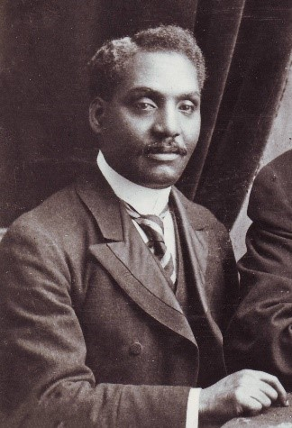
Dr John Alcindor (1873-1924)

Born in Trinidad, Dr John Alcindor was a physician and activist for racial equality, who helped others during the first world war despite facing prejudice and discrimination. Although he had a medical degree from Edinburgh University and having worked in several London hospitals for many years, he was rejected by the Royal Army Medical Corps during the war because of his origin.
Dr Alcindor persisted with his desire to help those in need by joining the British Red Cross as a volunteer and treated countless wounded soldiers at London railway stations as they returned from the battlefields. He was later awarded a Red Cross medal for his life-saving work.

He also conducted research and published articles on cancer, influenza and tuberculosis and worked to prevent syphilis and tuberculosis in Great Britain. His research set the groundwork for the correlation between poverty, low quality food and unbalanced diets in poor health.

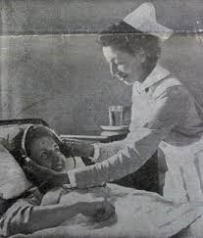
Princess Tsehai (1918-1942)

Princess Tsehai was the daughter of Haile Selassie of Ethiopia, born in Addis Ababa. She joined her father in exile in London and trained as a state registered nurse in 1939 at Great Ormond Street for Sick Children. After the restoration of her father in 1941, she returned to Ethiopia to work in Dessie Hospital. Sadly, Princess Tsehai in 1942 died from complications during childbirth; her baby also did not survive. Emperor Haile Selassie founded the Princess Tsehai Memorial Hospital in her memory which was also funded by British admirers that were very moved by her death. The hospital was also created to serve as a nursing school.

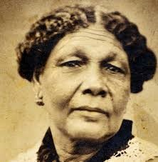
Mary Seacole (1805- 1881) Nursing
Born and raised in Jamaica, Mary came to England in 1854 after the start of the Crimean War to join the British War Office to go and help wounded soldiers in Ukraine. She was flatly refused despite her valuable education in Caribbean and African medicine.
Instead, she decided to raise money for herself to travel to Balaclava, Ukraine and set up the British Hotel, where she could tend to the injured soldiers. She also visited the battlefield to treat the wounded and became known as 'Mother Seacole'.
She returned to England after the war penniless and in ill health. The newspapers discovered her story, and in 1857 Queen Victoria's nephew hosted a benefit in her name, attracting thousands of people and raised plenty of funds for her.
Mary later published her memoir, 'The Wonderful Adventures of Mrs Seacole in Many Lands'.

Extension activity: Humanitarians you admire
Ask learners to research Black British people they know that they consider to be humanitarians or that they admire for their good work.

This could be someone famous or well known, or someone from your everyday life. Refer learners back to their definition of a humanitarian. Learners could create a presentation or mind map exploring the following question: 'What makes them a humanitarian?’

Encourage learners to search for Black British humanitarians specifically. Introduce this task with a discussion around the following questions:
- Why is it important to have a range of positive role models?
- Why is it important to recognise people’s contribution?
- Why is it good to share stories about all kinds of people?

