Fleeing violence in Myanmar

Due to violence in Myanmar, hundreds of thousands of people have been forced to flee to Bangladesh in fear of their lives. This activity provides learners with the opportunity to reflect on the crisis by considering some of the individuals involved and thinking about what people really need in a situation like this.

Activity 1 – exploring the photograph
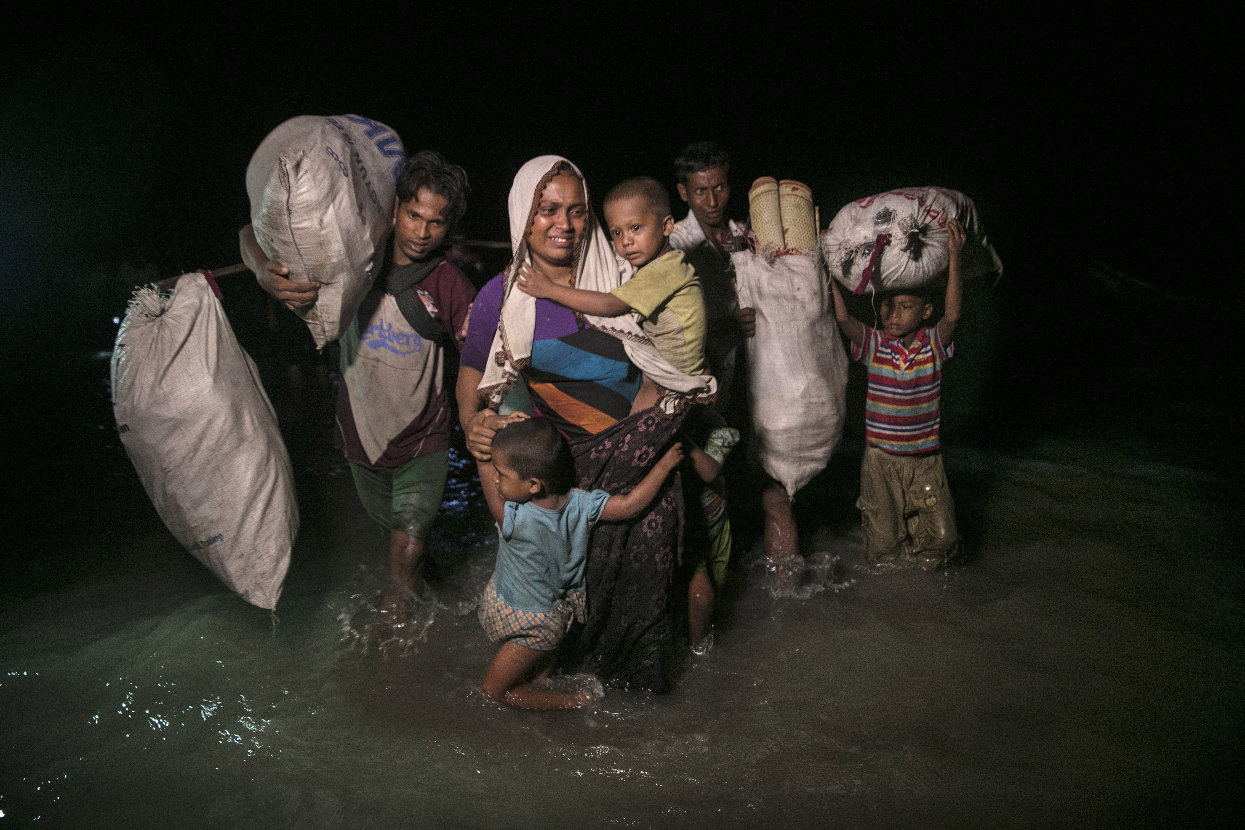

Display this photograph without giving any information about it. Invite your group of young people to:
- suggest where they think these people are and what is happening to them.
- consider what their mood or attitude appears to be. Do they seem determined, tense, serious, doubtful? Try to agree on a phrase that describes the scene and write this on the board. You will revisit this phrase later in the activity.
The group are among hundreds of thousands of people who have fled violence in Rakhine State, Myanmar. They, like most of the people fleeing violence from this region, have crossed the border into Bangladesh. Their route took them by boat across the Naf River to a city, Cox’s Bazar.

Conditions around Cox’s Bazar are extremely hard. Makeshift camps and settlements are overflowing with people, mainly women and children. UK charities have joined together to launch a Disasters Emergency Committee appeal for funds to help.

Explain that these people have fled the violence in Rakhine State, Myanmar and have now arrived in a temporary settlement in Bangladesh. Encourage the young people to say what they know of the crisis and the emergency conditions these people are experiencing. To prompt this discussion, you could ask them:

- What kind of immediate help might they need?
- What things might they have brought with them?
- What kind of help might they need in the long term?
- How might they be feeling?
Look again at the photograph. Remind the young people of the descriptive phrase written on the board. Does knowing more about the group’s circumstances change the way they look at the picture? Do they want to change the phrase or add to it?

Divide the class into small groups. Assign a different person in the photograph to each group. Encourage the groups to reflect on this person, thinking about:

- What might they normally be doing or worrying about at home? (For example, the woman in the photo may normally worry about caring for her family.)
- How do you think they might be feeling at this moment? (Remember that they have arrived in darkness.)
- What might be their main concerns at this moment? (For example, finding somewhere safe and clean to sleep, getting some drinking water, worrying about friends and family being safe.)
- What do you think they might be most concerned about in the morning? (For example, they may think about finding missing friends or family, finding somewhere more permanent to live, getting work or not having any ID to prove who they are.)
Invite the groups to share these thoughts with the whole class and compare their ideas. Bear these ideas in mind for the following activities.

Activity 2 – creative activity ideas

Role play activity:

- Working in pairs, ask the young people to imagine a dialogue that takes place between two of the people, before they get to rest that night. It could be a child talking to an adult. Or two children discussing what’s happening.
- How might they express their fears? What sort of language might be comforting? What kind of comments might not be so helpful?
or

Written activity:

- Ask the young people to put themselves in the place of one of the people in the photograph and to write a letter as this person to a friend, reflecting on the journey they’ve made and the fears they now have.
- Collect the letters and distribute among the class so that everyone now has a letter that they did not write.
- Ask the young people to write a reply to this letter as if from their friend, thinking about the words of comfort and understanding that they could use.
In either activity, the person could look back on the journey they’ve made – leaving their home and the situation they have come from – as well as thinking about the next few days and weeks in a makeshift shelter and with few of the basics of life.

Bring the group back together and reflect on how this exercise has made them feel and the words of comfort that they used. What message would the group like to send to the people in the photograph and those in a similar situation?

This resource was written by P. J. White of Alt62 and published in October 2017.

